**Biology Revision: Photosynthesis**

Mastery Matrix Points

|  |
| --- |
| Describe the process of photosynthesis |
| Recall the word and symbol equation for photosynthesis |
| Explain the effects of temperature, light intensity, carbon dioxide intensity and the amount of chlorophyll on the rate of photosynthesis |
| Analyse data and calculate rates of photosynthesis and limiting factors from graphs and tables |
| **Required Practical: Investigate the effect of light intensity on the rate of photosynthesis on an aquatic plant** |
| Describe how glucose is used after photosynthesis |
| Explain the use of nitrate ions within plants |

Key Knowledge

Photosynthesis

Definition

Word equation:

Symbol equation:

Four limiting factors of photosynthesis:

-

-

-

-

Equation:

Rate of reaction =

Uses of glucose after photosynthesis

-

-

-

-

-

C

B

A

Understanding and Explaining

1. Describe the limiting factors at points A, B and C on the graph.

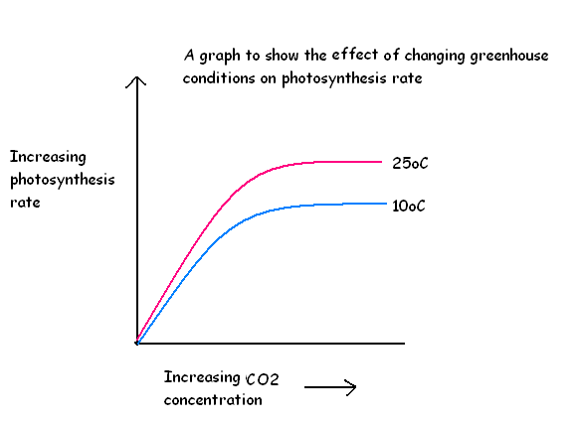

1. Explain the importance of nitrate ions in healthy growth of a plant.
2. Describe the process of photosynthesis in detail.
3. Explain how farmers must balance increasing limiting factors with costs to ensure maximum profit.